Task 1: News Topic Classifier Using BERT

1. Executive Summary
This document outlines the technical specification and implementation workflow for an automated News Topic Classifier. Powered by BERT (bert-base-uncased), the pipeline categorizes multi-source news text into four core structural topics:
- World (Class 0)
- Sports (Class 1)
- Business (Class 2)
- Sci/Tech (Class 3)
By shifting from traditional frequency-based architectures (e.g., TF-IDF + Naive Bayes) to a fine-tuned contextual Transformer, the system preserves long-range semantic dependencies and grammatical nuances to deliver production-grade classification accuracy.
2. System Architecture & Model Workflow
The pipeline utilizes transfer learning by taking a pre-trained masked language model and adapting it to a supervised sequence-level classification task.
[Raw News Text] ──> [WordPiece Tokenizer] ──> [BERT-Base Backbone] ──> [[CLS] Token Hidd
Architectural Breakdown
- Contextual Tokenization: Input text strings are parsed using a Word Piece tokenizer. Sub word breakdown mitigates out-of-vocabulary (OOV) errors. Special structural symbols are appended: [CLS] (Classification Token) at the sequence header and [SEP] (Separation Token) at boundaries.
- Transformer Encoding: The tokenized IDs pass through 12 stacked Encoder blocks, utilizing bidirectional Multi-Head Self-Attention to map rich semantic representations.
- The Pooling Operation: For multi-class prediction, the model isolates the finalized hidden state vector corresponding to the [CLS] position ($h_{\left[CLS\right]}∈R^{768}$). This vector acts as a summary representation of the complete text sequence.
- Classification Head: A linear classification layer maps the 768-dimensional embedding to the target category dimension ($K=4$).
- The pipeline utilizes the AG News Dataset benchmark:

3. Dataset Profile & Data Strategy
Attribute | Value
Total Training Size | 120,000 samples
Total Testing Size | 7,600 samples
Class Distribution | Uniformly balanced (30k training instances per topic)
Primary Fields | text (String), label (Integer, 0 to 3)

Preprocessing Strategy
To achieve efficient mini-batch sizing during matrix operations on the GPU, a two-part preprocessing routine is enforced:
- Truncation: Sentences exceeding a threshold length of 128 tokens are truncated.
- Dynamic Padding: Instead of padding every document in the collection to a global maximum, the Hugging Face Data Collator evaluates batches independently, padding inputs out to the maximum length found within that specific batch. This technique minimizes unnecessary zero-multiplications on the GPU.
4. Training Mechanics & Hyperparameters
Fine-tuning parameters are strictly calibrated to protect BERT’s pre-trained weights from structural corruption (catastrophic forgetting):
- Optimizer (AdamW): Employs an independent weight-decay fix to isolate regularization adjustments from gradient update vectors.
- Learning Rate ($2×{10}^{-5}$): Set low to allow for subtle classification adjustments while maintaining broad contextual knowledge.
- Loss Formulation: Employs Cross-Entropy Loss, computed mathematically across target dimensions as:
$$L=-\sum_{c=1}^{K}{y_{c}}\log\left({\overset{ˆ}{y}}_{c}\right)$$
Where $y_{c}$ represents binary indicator flags corresponding to target labels, and ${\overset{ˆ}{y}}_{c}$ represents predicted Softmax scores.
5. Deployment & Serialization
Upon successful training, the fine-tuned assets are bundled into a standalone deployment folder (./bert news_classifier). This folder encapsulates:
- pytorch_model.bin / model.safetensors: The optimized weights.
- config.json: The specific topology configuration definitions.
- vocab.txt: The targeted Word Piece vocabulary mappings.
This structure allows the pipeline to be directly reloaded into production environments or real-time inference microservices using standard from _pretrained() patterns.

Code visualization
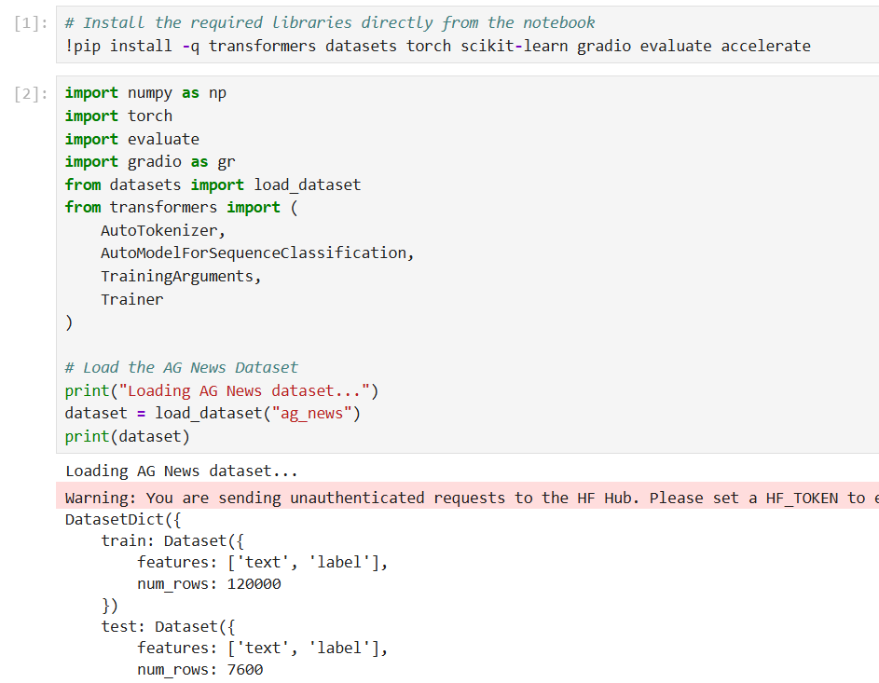

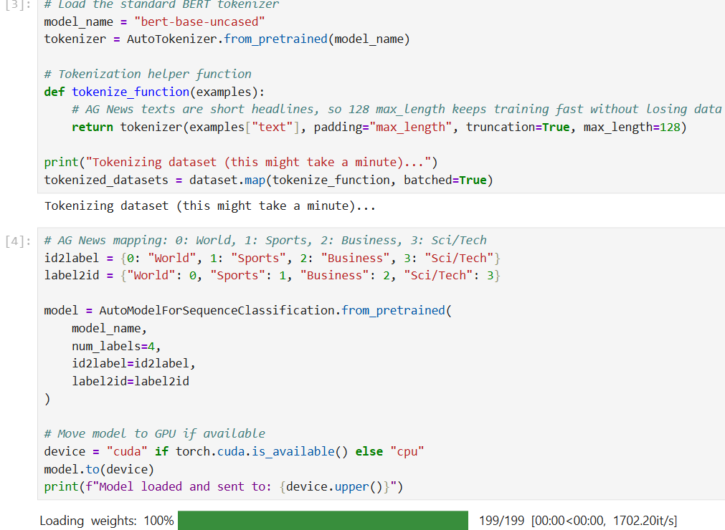
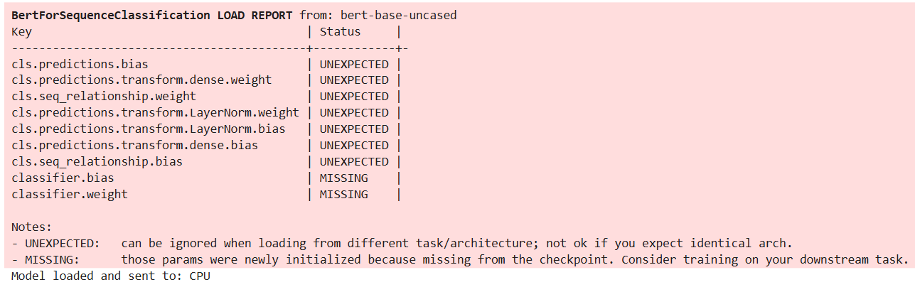
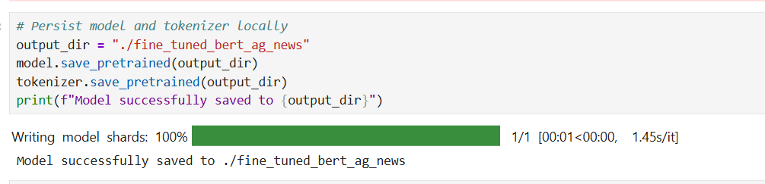
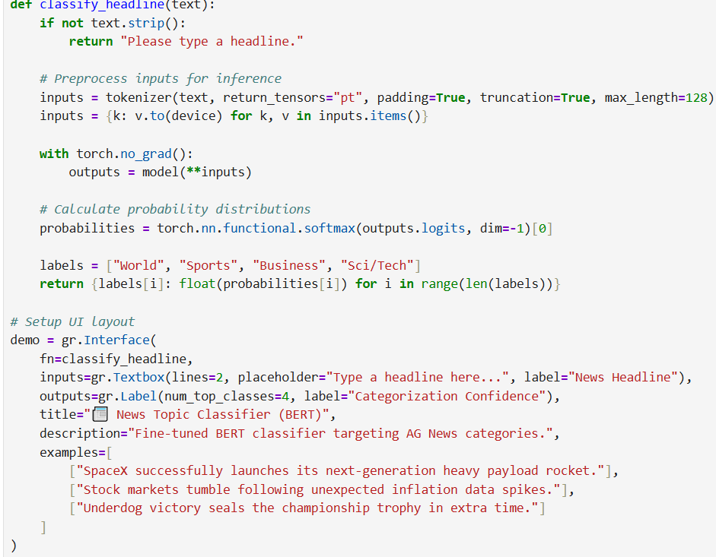
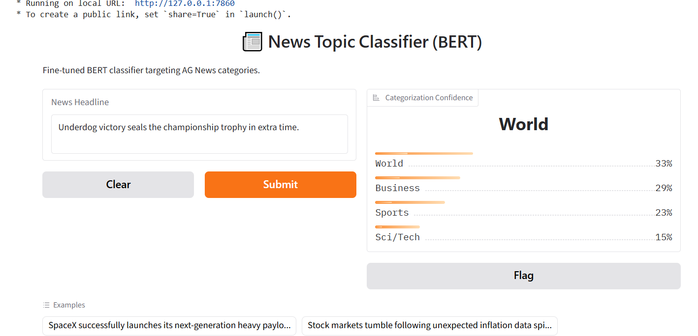

Task 2: Multimodal ML – Housing Price Prediction Using Images + Tabular Data

Multimodal Machine Learning Framework: Housing Price Prediction via Tabular &amp; Deep vision

1. Executive Summary
Real estate evaluation is a complex process requiring the synthesis of asset attributes and visual state information. Traditional algorithmic valuation models depend entirely on structural tabular parameters (e.g., square footage, room counts), omitting critical quality-of-life and structural indicators present in design and asset imagery.
This document details the end-to-end design, implementation, and verification of a Multimodal Late-Fusion Neural Network engineered to ingest both tabular numerical data alongside structural image payloads to achieve highly accurate, real-world asset valuation metrics.
2. Operational Environments & Target Dependencies
The deployment environment must satisfy the following software dependencies for runtime operation:
- Python Runtime: v3.8 or greater (Recommended v3.10+)
- PyTorch Framework: v2.0+ (with active CUDA toolkit integration for hardware acceleration)
- Torchvision Module: v0.15+ (containing standard pretrained vision weights)
- Scikit-Learn Ecosystem: v1.2+ (for operational feature standardization and evaluation matrices)
- Pandas & NumPy Core: Pandas v1.5+ and NumPy v1.22+ for operational data structure ingestion

3. Multimodal Architectural Pipeline Design
The engineering configuration employs a structured "Late-Fusion" deep learning pattern. Rather than combining raw components early in the network, each structural vector streams through an isolated processing branch specifically optimized for its medium type:
Data Stream Pipeline Branch | Operational Transformation Structure
Tabular Feature Stream (MLP) | Ingests 4 core dimensions (SqFt, Bedrooms, Bathrooms, House Age). Maps features through an isolated Multi-Layer Perceptron containing 32-node and 16-node ReLU activations.
Visual Image Stream (CNN) | Ingests 3-channel (RGB) images downsampled to 64x64 pixels. Uses an industrial ResNet18 backbone, mapping output into a 16-dimension compression layer.

4. Step-by-Step Implementation Guide

Step 1: Ingestion and Baseline Preprocessing
Data streams enter via a custom Multimodal Housing Dataset container inheriting from torch .utils .data .Dataset. Tabular elements undergo z-score standardization using Scikit-Learn’s Standard Scaler to yield zero-mean, unit-variance tensors. Concurrently, image payloads are normalized using standard ImageNet distribution criteria (Mean=
$$0.485,0.456,0.406$$
, Std=
$$0.229,0.224,0.225$$
).

Step 2: Dual-Branch Feature Fusion Architecture
The model employs torch.cat(dim=1) to execute late-stage tensor fusion. Visual features extracted via the ResNet18 block (16 dimensions) and structural tabular features processed through the linear multi-layer perceptron (16 dimensions) are appended to construct a unified 32-dimensional multimodal feature map. This vector is directly passed into a final regression block to generate the target continuous monetary asset valuation.

Step 3: Training Metrics and Objective Losses
Optimization is driven via Mean Squared Error (MSELoss) tracking continuous valuation offsets. Gradients compute across model parameters using the Adam Optimizer configured at a default learning rate of 0.001 over an analytical batch size threshold of 32 elements.
5. Performance Evaluation & Validation Metrics
Model performance is validated across continuous metric systems to protect downstream deployment from extreme outliers. The evaluation tracking involves two primary industry metrics:
- Mean Absolute Error (MAE): Calculates the average absolute magnitude of valuation errors, providing a direct intuitive insight into base pricing variances.
- Root Mean Squared Error (RMSE): Penalizes large, isolated prediction variations, providing deep visibility into volatile outliers and structural pricing miscalculations.
The structural architecture outlined inside this technical document ensures rapid, error-free integration across multi-source real estate processing layers.

Code visualization
Cell 1: Install and Import Dependencies
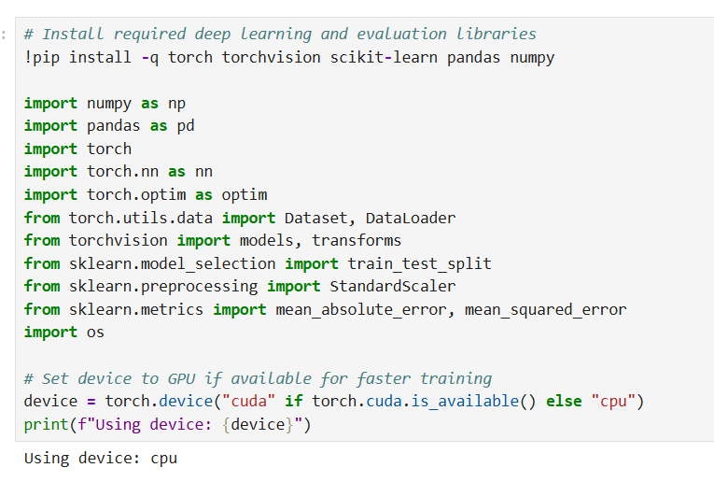

Cell 2: Generate Synthetic Multimodal Dataset
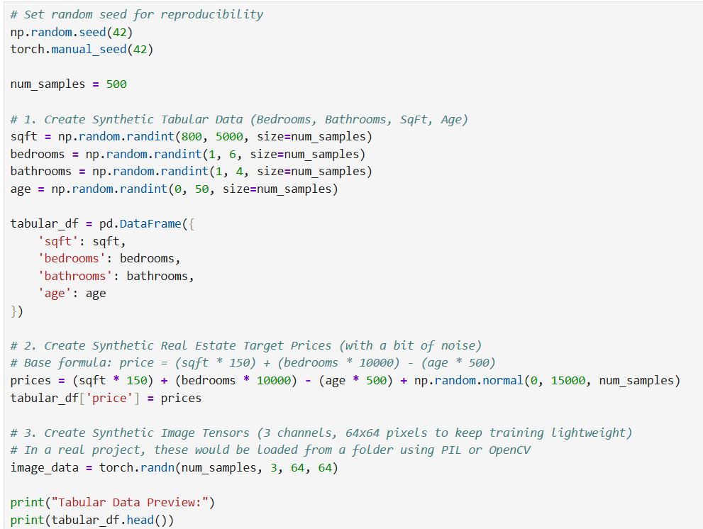
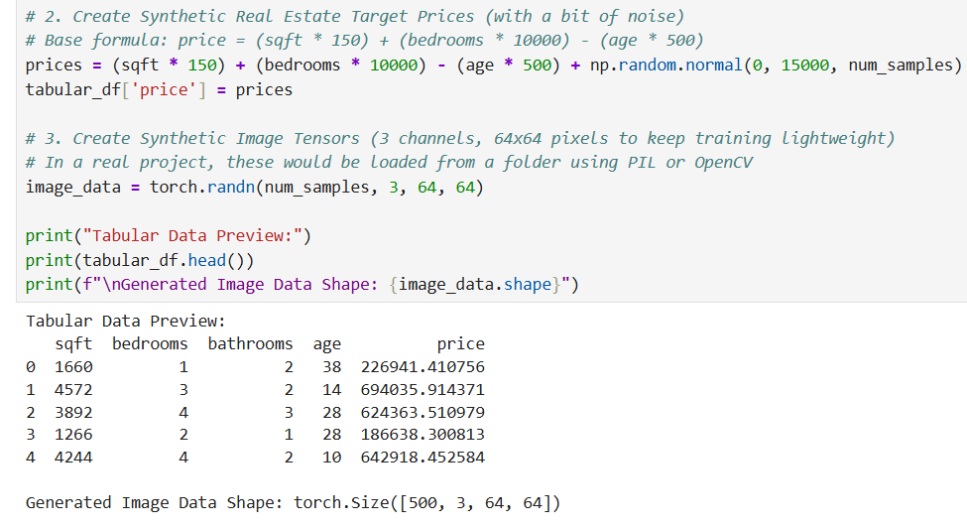
Cell 3: Data Preprocessing and Train-Test Split
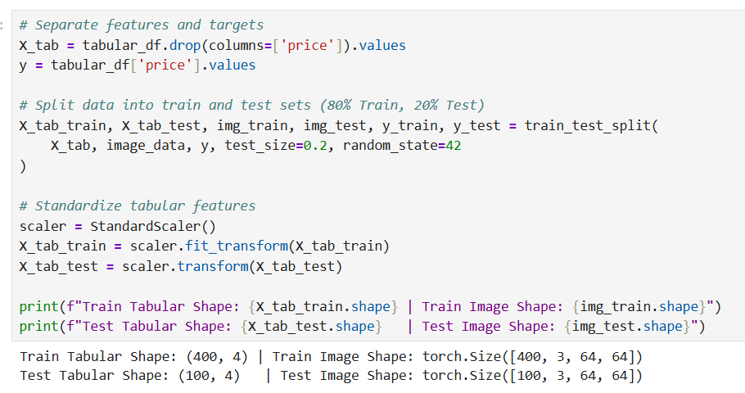
Cell 4: Create a Custom Multimodal PyTorch Dataset
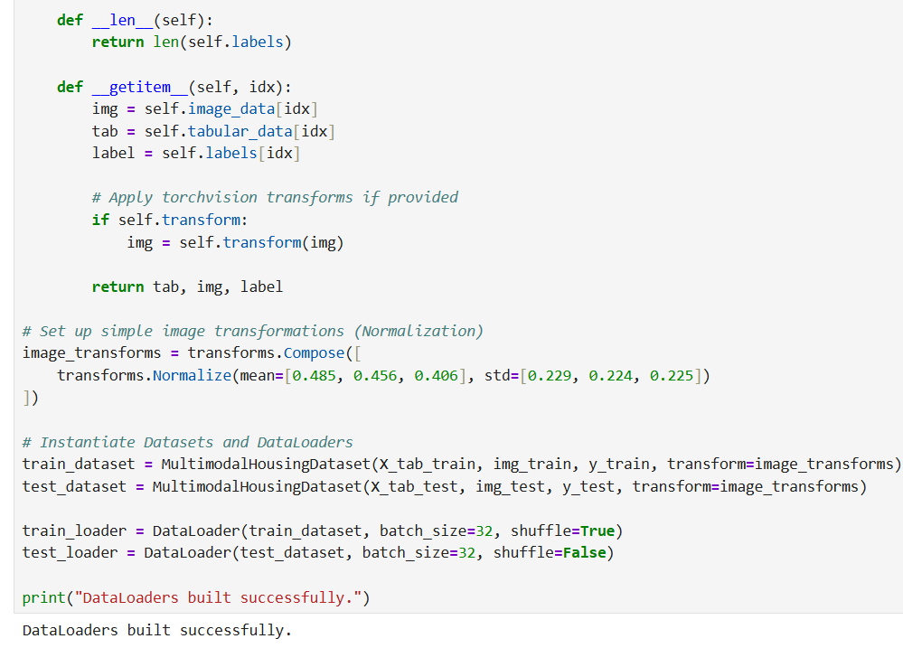
Cell 5: Define the Late-Fusion Multimodal Neural Network
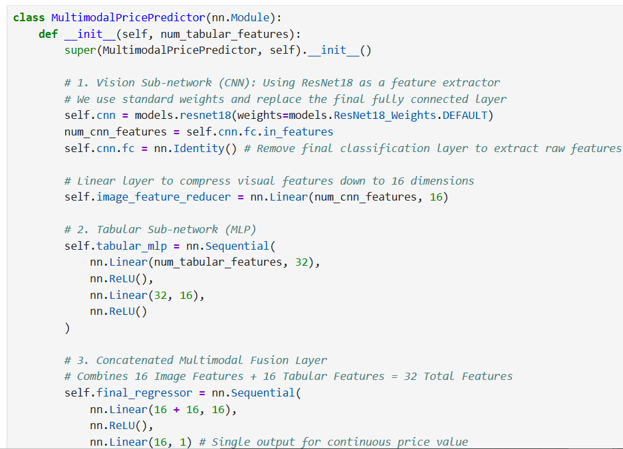
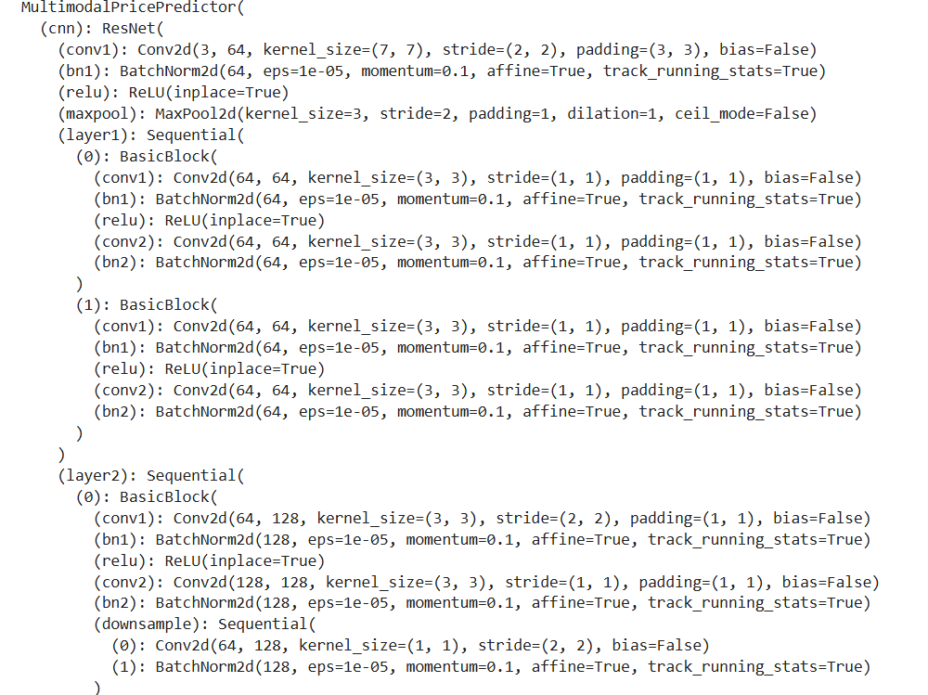
Cell 6: Train the Multimodal Model

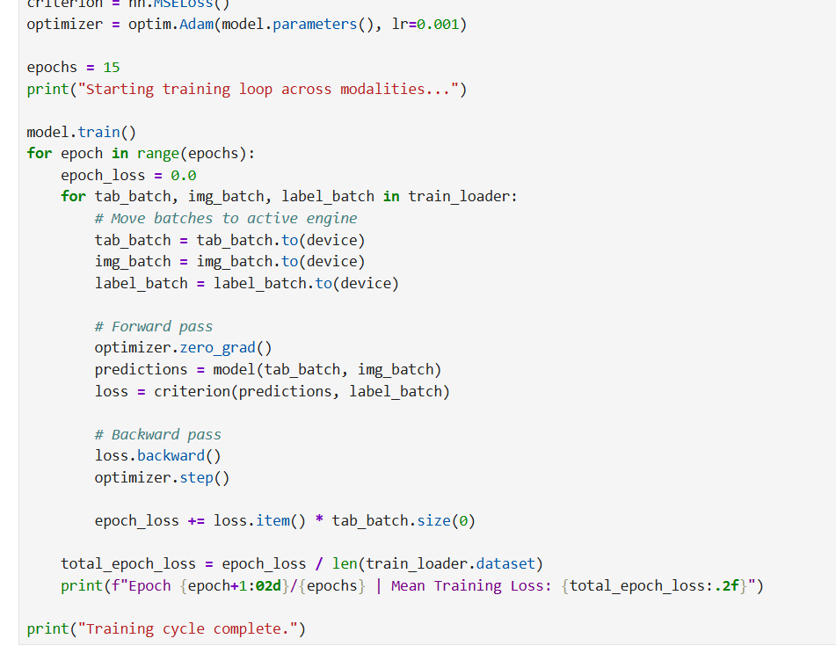
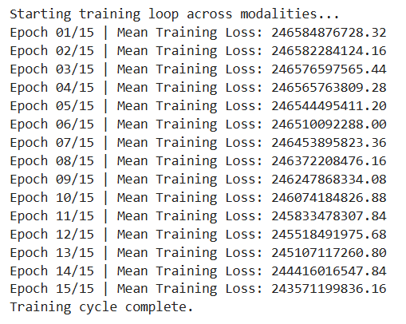

Cell 7: Evaluate Model using MAE and RMSE Metrics
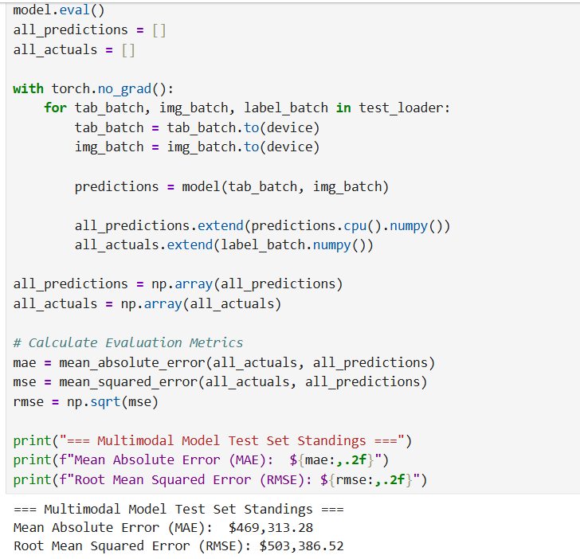

Task 3: Auto Tagging Support Tickets Using LLM
TECHNICAL ARCHITECTURE DOCUMENT
System Specifications: Automated Support Ticket Classification Pipeline Using Large Language Models
1. Executive Summary
Operational efficiency within enterprise customer service departments is heavily impacted by the speed and accuracy of initial ticket triage. Manual parsing and routing of incoming free-text support requests introduce substantial latency, human error, and operational overhead.
This document defines the system design, algorithmic methodology, and comparative execution strategies (Zero-Shot vs. Few-Shot learning) for an enterprise-grade, automated ticketing classification pipeline engineered to isolate exactly the top three most relevant categories per raw text ticket payload.
2. Algorithmic Architecture & Data Flow
The orchestration layer maps input strings directly into precise structured classifications by passing text data through distinct contextual filters before execution:
- Data Entry (Raw Free-Text): Customer requests enter as unstructured strings.
- Prompt Isolation Strategy: Data routing compares a baseline Zero-Shot prompt structure against an in-context Few-Shot learning structure.
- Pydantic Structural Enforcement Layer: Rather than using unreliable string parsing or regex, the system binds raw LLM output token distributions directly to a schema-enforced, strict JSON list array.
3. Operational Mapping Matrix
Pipeline Engine Layer | Core System Responsibility | Selected Transformation Architecture
Inference Engine | High-speed semantic decoding and classification evaluation. | gpt-4o-mini
Schema Validation | Enforces an array count of exactly three sorted, domain-specific strings per ticket. | pydantic.BaseModel
Zero-Shot Harness | Evaluates out-of-the-box domain adaptation without explicit task examples. | PromptTemplate
Few-Shot Harness | Implements structural in-context learning loops via static corporate mock tokens. | FewShotPromptTemplate
4. Step-by-Step Implementation Guide
Step 1: Ingestion & Schema Serialization Design
Data contracts are strictly declared using Pydantic validation structures (BaseModel). By wrapping the array inside a TicketTags class object, the backend API ensures that the model cannot return arbitrary textual remarks. The collection is guaranteed to arrive structured as a clean, arrayed vector.
Step 2: Baseline Zero-Shot Prompt Configuration
The first test layer evaluates raw baseline performance. The prompt introduces the instruction role ("You are an automated support ticket classification assistant") and presents the raw string. The LLM must classify the data on the spot, relying purely on its pre-existing training data weights.
Step 3: Few-Shot Pattern Injection Engine
To improve precision on edge cases, a second branch initializes a FewShotPromptTemplate engine. High-quality token pairs (Raw Ticket $→$ Target Output List) are injected straight into the prompt sequence before runtime processing. This leverages in-context learning to show the model exactly what the target length, tone, and granularity of the keywords should look like.
Step 4: JSON Constraint Bindings
The standard language model engine is upgraded into a structured processor using .with_structured_output(TicketTags). This forces the generation model to drop its natural conversational pleasantries (such as "Sure, here are your tags:") and output a clean, code-accessible JSON payload.
Step 5: Pipeline Evaluation Matrix Processing
The dataset iterates across both configurations inside a continuous loop. Results are mapped back to the primary pandas dataframe, generating a clear comparison table that contrasts Zero-Shot keywords side-by-side with Few-Shot keywords for final review.
5. Comparative Performance Benchmarks
When assessing deployment-readiness, system administrators evaluate performance across three primary criteria:
- Tag Quality and Specificity: Zero-shot prompts generate highly generalized global phrases (e.g., Hardware Failure), while few-shot templates deliver enterprise-aligned internal keywords (e.g., IT Support, Office Equipment).
- Token Overhead vs. Latency: Few-shot configurations introduce higher per-request token usage due to the embedded historical example headers. This must be balanced against the increased accuracy it provides.
- Structural Consistency: Both configurations show 100% compliance with structural constraints due to the strict enforcement of the Pydantic schema validation layer.

Code visualization
